Objectives:

* Creating Lists and Tuples

**There are 3 projects, each is worth 33.3%.**

**Project #1:** write the following program and get the output in a console and a text file.

**#1 print screen the output with code below here.**

**Code**

**# This program asks the user to enter a series of test scores and**

**# calculates the average of the scores with the lowest score dropped.**

**def main():**

**# Get the test scores from the user.**

**scores = get_scores()**

**# Get the total of the test scores.**

**total = get_total(scores)**

**# Get the lowest test score.**

**lowest = min(scores)**

**# Subtract the lowest score from the total.**

**total -= lowest**

**# Calculate the average.**

**average = total / (len(scores) - 1)**

**# Display the average.**

**print(f'The average, with the lowest score dropped is: {average:,.2f}')**

**outputfile = open("lowest scores.txt", 'w')**

**outputfile.write( str(f'The average, with the lowest score dropped is: {average:,.2f}'))**

**outputfile.close**

**# The get_scores function gets a series of test**

**# scores from the user and stores them in a list.**

**# A reference to the list is returned.**

**def get_scores():**

**# Create an empty list.**

**test_scores = []**

**# Create a variable to control the loop.**

**again = 'y'**

**# Get the scores from the user and add them to**

**# the list.**

**while again == 'y':**

**# Get a score and add it to the list.**

**value = float(input('Enter a test score: '))**

**test_scores.append(value)**

**# Want to do this again?**

**print('Do you want to add another score?')**

**again = input('y = yes, anything else = no: ')**

**print()**

**# Return the list.**

**return test_scores**

**# The get_total function accepts a list as an**

**# argument returns the total of the values in**

**# the list.**

**def get_total(value_list):**

**# Create a variable to use as an accumulator.**

**total = 0.0**

**# Calculate the total of the list elements.**

**for num in value_list:**

**total += num**

**# Return the total.**

**return total**

**# Call the main function.**

**main()**

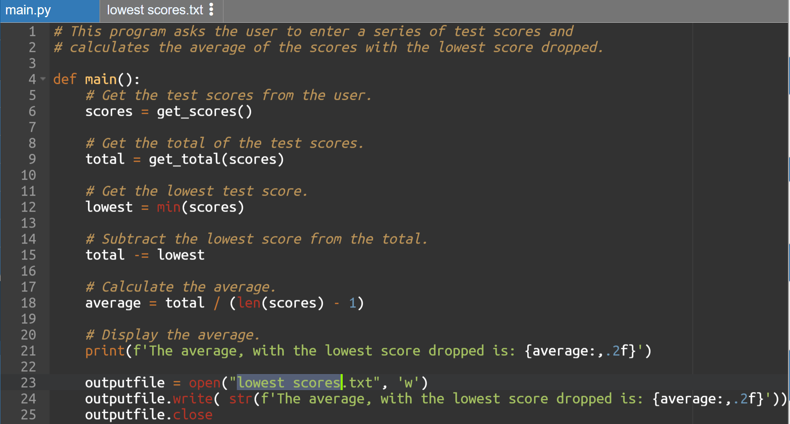



**Project #2:** complete the following program below

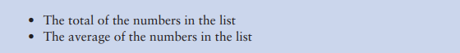

**#2 print screen the output with code below here.**

# CMPR114

# Number Analysis Program

# Declaration

numbers = []

total = 0

# input - enter a series of 20 numbers.

for i in range(20):

number = int(input(f'Enter a number #{i+1} (of a series of 20 numbers): '))

# store the numbers in a list

numbers.append(number)

total += number

# output

print('The lowest number in the list is', min(numbers))

print('The highest number in the list is', max(numbers))

print('The total in the list is', total)

print('The average in the list is', total / 20)

